

**JOMO KENYATTA UNIVERSITY OF AGRICULTURE AND TECHNOLOGY**

**SCHOOL OF ELECTRICAL, ELECTRONIC AND INFORMATION ENGINEERING**

**DEPARTMENT OF ELECTRICAL AND ELECTRONIC ENGINEERING**

**FINAL YEAR PROJECT PROPOSAL**

**KELVIN WAITHAKA KIHUMBA EN271-9512/2015**

**GICHURU IAN KAIMENYI EN271-9511/2015**

**SUPERVISOR:** MR BAARIU

**INTELLIGENT ROBOTIC LAWN MOWER MODEL**

A Final Year Project Proposal submitted to the Department of Electrical and

Electronic Engineering in partial fulfillment of the requirements for the award of a Bachelor of Science Degree in Electrical and Electronic Engineering.

**DECLARATION**

This project proposal is our original work and is not the result of any plagiarism. Due acknowledgement has been done in various sections of the text where we have referred to previous researches. To the best of our knowledge, this project not been previously submitted to Jomo Kenyatta university of Agriculture and technology.

Gichuru Ian Kaimenyi …………

Waithaka Kelvin Kihumba ………….

**SUPERVISOR CONFIRMATION:**

This project proposal has been submitted to the Department of Electrical and Electronic Engineering, Jomo Kenyatta University of Agriculture and Technology, with my approval as the supervisor:

NAME: MR. A.M. BAARIU

SIGNATURE………………………………………… DATE ………………………………

**Table of Contents**

LIST OF FIGURES iv

LIST OF ABBREVIATIONS v

1. INTRODUCTION 1

1.1BACKGROUND INFORMATION 1

1.2 PROBLEM STATEMENT 2

1.3 PROBLEM JUSTIFICATION 2

2. OBJECTIVES 4

2.1Main Objective 4

2.2Specific Objectives 4

3. LITERATURE REVIEW 5

3.1 LAWN MOWING MILESTONES 5

3.2 HUMAN – ROBOT INTERACTION 5

3.3 PATTERN RECOGNITION IN ROBOTS 6

3.4 PERIMETER RECOGNITION FOR SMALL ROBOTS 7

3.5 ROBOTIC SENSORY TECHNOLOGIES 9

3.6 THE COMPLEXITIES OF ROBOT MOTION PLANNING 15

4. METHODOLOGY 18

4.1 Project modules 18

4.2 Top Down design 21

4.2.1 Device Requirements and Analysis 22

4.2.2 Navigation and Guidance System 22

4.2.3 Hardware Configuration and Testing 24

4.2.4 Integration and Testing 24

4.2.5 Module Testing 24

4.2.6 Integration Testing 24

4.2.7 System Testing 24

4.3 Implementation 24

4.4 Software and Design Simulations 25

5. EXPECTED RESULTS 26

6. PROJECT TIME PLAN 27

6.1 PROPOSED PROJECT BUDGET 28

7. REFERENCES 29

**INTELLIGENT ROBOTIC LAWN MOWER MODEL**

Kelvin Kihumba & Gichuru Ian

Department of Electrical and Electronic Engineering, JKUAT

###### ABSTRACT

What is a robot? Isn’t that the question everyone seems to ask nowadays? According to the dictionary, it can be defined as *A machine capable of carrying out a complex series of actions automatically, especially one programmable by a computer –* Oxford dictionary. A lawn mower is a machine for cutting the grass on a lawn. This is a common tool in estates, sporting organizations, schools and institution and even homes. In this project, the aim is to design and model a low cost robotic lawn mower that need no supervision while cutting grass on a lawn or field unlike the ‘walk behind’ mower.

The project seeks to automate lawn mowing by creating a versatile robotic model that will have a wide array of sensors to help it move along a patch of land as specified by the owner. We find that in various settings grass on a filed doesn’t necessarily grow evenly. Ultrasonic sensors will be used for proximity alertness and obstacle avoidance. A virtual perimeter by application of signals and communication concepts to ensure that the robot isn’t dependent on physical walls to perform its tasks.

This project seeks to provide new approaches to already existing problems.

## LIST OF FIGURES

1. Push mower sketch
2. Ride on lawn mowers
3. Push reel mower

## LIST OF ABBREVIATIONS

1. Robomower/Automower
2. Buried wire fence (BWF)
3. Bot
4. Infrared receivers and transmitters (IR)
5. Inertial Measurement Unit (IMU)

CHAPTER 1

# 1. INTRODUCTION

## 1.1BACKGROUND INFORMATION

This project involves the modelling of a robotic lawn mower that is cost effective and designed to operate in day-to-day operations with minimal human interference or supervision. The regular push mower has many disadvantages, which we seek to eliminate in this project. The robotic mower will have unsupervised cutting capabilities while utilizing a wide array of sensors, transmitters and receivers to effectively achieve the desired purposes. The project is to be conducted in modules that will later be combined to realize the end device. Consequently, it will be easier to improve its performance while trading off between the cumulative cost and circuit complexity.

Detailed descriptions of various elements including hardware, software and mathematical calculations and assumptions made will be provided. The project brings new approaches to existing technology while also aiming at making these devices cost effective and timely. The project employs various science and technology principles combining with engineering knowledge to achieve a complex task.

The end device that this project seeks to come up with will have a great deal of versatility in various fields of employment. The final design will comprise of aspects of programming and machine learning, hardware and software interfacing and a new approach to mapping.

## 1.2 PROBLEM STATEMENT

The cost of any device in today’s market plays a pivotal role in terms of its use, preferences and application by majority of users despite the quality the device might offer in comparison to other similar devices. The current market offers two major variations in lawn mowing. The popular push mower or walk behind mower and the automower. The push behind mower has numerous disadvantages such as extreme time wasting, as it requires manual operation, extremely noisy, constant breakdowns since it is majorly mechanical and it is expensive to maintain. The currently available models of automower are very expensive some even rated at **$3,500, which** roughly translates to 362,775.00 Kenya shillings; this is obviously a lot of money to spend on a lawn mower.

This then brings up the need for a time saving yet efficient and cheap device that can do the work with as little supervision as possible.

## 1.3 PROBLEM JUSTIFICATION

A cheap, affordable and efficient device has a better or higher economic rating to the end users who more often than not find themselves choosing between various devices based on their cons and pros. At the end of the day, we find that the major considerations are price and efficiency. This lawn mower model is projected to be cheaper and have superior mowing pattern that will lead to higher efficiency while having widespread local applications.

The user projects it to be time saving and highly effective with a user interface that will allow for communication with the device for custom inputs. It is environmental friendly since it does not emit heat, radiation or any form of gases. This is because it is purely electric as compared to the push mowers, which mostly run on diesel or petrol engines. Based on its electric nature we also project that it will be significantly quitter and with much less vibrations throughout its body.

Our design further supports the slight modification should the manufacturer chose it, to be modeled into a vacuum cleaner. Thus, clearly showing the versatility of this design. The Kenya vision 2030 well on its tracks, hinges on increased productivity of her people. Their productivity is considered in this model since it does not require supervision, fulltime, as in the case of the push mowers.

CHAPTER 2

# 2. OBJECTIVES

## 2.1Main Objective

* To design a low cost and more efficient intelligent robotic lawn mower that has a communication interface with an android smartphone.

## 2.2Specific Objectives

* Build a robotic lawn mower
* To confine the robot within a non-physical fence (virtual fence)
* To design a more efficient mowing pattern
* Integrate to an android smartphone

CHAPTER 3

# 3. LITERATURE REVIEW

## 3.1 LAWN MOWING MILESTONES

Over the years, some basic questions have been guiding the development of lawn mowing. Some of these questions have been pivotal in the lawn mowing technological advancements. Some of these questions are:

* Material resources
* Time and talent
* Lawn condition
* Height of the grass

As a result, various techniques have been emerging even some as basic as the slasher. We find that there are five major types of lawn mowers:

1. Push reel mower
2. Walk behind power lawn mower
3. Ride on lawn mowers
4. Hover mowers
5. Robotic mower.

We find that the first four have one crucial disadvantage, time consuming. However, the robotic lawn mower eliminates this entirely because as soon as it is powered on, the owner can take up other tasks while the Robomower does all the mowing often unsupervised.

## 3.2 HUMAN – ROBOT INTERACTION

This is a field where investigation includes development of new techniques for the purpose of transfer of instructions or knowledge and a machine in such a way that it can be actionable. This means that the machine can accomplish tasks and report. The success in this field are hinged upon good interface systems that usually rely on engineering and programming knowledge.

Robots are artificial agents that possess capacities of perception, decision making and action in the real world often referred to as workspace by researchers and engineers. Their use was initially generalized to industrial use but with technological advancements, they are now found in complex fields such as space and scientific explorations, military operations, search and rescue and even home care situations that more often than not require advanced decision-making algorithms.

These new fields imply a closer relationship with the user as compared to a few years back when the user was always giving instructions and more often than not supervising the work. This new concept of closeness has to be taken to its full meaning, in that the robot and the user share goals when it comes to task achievement.

Advancements in AI are focusing their attention of further automation of machine with one of the key guiding factors being the safety of the user and task achievement efficiency. For efficient task execution, the robot has to be able to understand the environment itself and this is made possible by a wide array of sensors from ultrasonic sensors to color sensors. This is all in an effort to properly distinguish objects in an environment and account for factors such as terrain variations.

## 3.3 PATTERN RECOGNITION IN ROBOTS

Intelligent robotic systems should be able to perform a range of complex tasks in unstructured and dynamic environments. Pattern recognition is a branch of machine earning that focuses on discerning different patterns and regularities or irregularities in data, although often considered synonymous with machine learning. Pattern recognition algorithms generally aim to provide a reasonable answer for all possible inputs and to perform ‘most likely’ matching of the inputs, taking into account their statistical variation.

Often pattern recognition is mistaken for pattern matching, which as the name suggests look for exact similarities between an input and already stored data consisting of various patterns. The piece of input data for which and output value is generated is formally termed as an instance. The instance is formally described by a vector of features, which together constitute a description of all known characteristics of the instance. These feature vectors can be treated as defining points in an appropriate multidimensional space (2D, 3D etc.), and methods for manipulating vectors in vector spaces can be correspondingly applied to them, such as computing the dot product or the angle between two vectors. Typically, features are either categorical, ordinal (a set of ordered items, for example, "large" or "small"), integer-valued (for example, a count of the number of occurrences of a particular word in an essay) or real-valued (for example, a measurement of body weight).

Mobile robots provide an attractive platform for combining electrical, mechanical, control, computer and communication systems for education and research. Mobile devices are mechanical devices capable of moving within a given environment with a certain degree of autonomy. This autonomous navigation is associated with the availability of external sensors. Performance of the robot is therefore dependent on the performance of the sensors and the control system’s efficiency. One such system is the fuzzy logic. Fuzzy logic controller (FL) as nonlinear control method is used for sensor outputs reasoning and robot navigation in many works.

## 3.4 PERIMETER RECOGNITION FOR SMALL ROBOTS

During the last few decades, there has been a considerable growth of interest in pattern recognition in

The field of robotics. An application of pattern recognition in robotics includes mobile robots and service robots. Visual and signal recognition of patterns enables the robots to perform a variety of tasks such as object and target recognition, navigation, grasping, and manipulation, assisting physically challenged people.

Robots can be guided by remote control or integrating sensors and enhancing automation where the robot can make certain decisions for itself such as where to stop. Certain surveillance robots have been known to employ 360-degree setup of high sensitive cameras. However, this approach limits the robot to only physical obstacles.

A perimeter wire is like a ‘virtual fence’. It is often referred to as buried wire fence (BWF). Through the application of a receiver and transmitter, it stops a robot when the bot reaches the boundary. The signal strength is directly proportional to the distance between the wire and the bot. something very interesting happens whenever a robot fails to stop in time hence crossing the boundary. The polarity of the signal changes alerting the robot that it is beyond the boundary.

The problem of pattern recognition involves decision making in most of the robotics applications. The process of preprocessing in pattern recognition of signal/image processing is required to remove noise and redundant data. In the decision making approach, the process consists of data segmentation, feature extraction and feature selection/reduction. After preprocessing of data, it is necessary to extract the features that will potentially help in decision-making. Features contain information and the extraction of relevant features for decision-making application depends upon the patterns and the number of decisions under consideration. Several approaches are available for extraction of features, selection of features and classification in different robotic applications.

Sonar location is an emerging technique that is causing robot experts to question the relative merits of sound waves versus camera vision when exploring new environments. This brings a robot inspired by sonar location as used by bats when locating prey and generally moving around.

## 3.5 ROBOTIC SENSORY TECHNOLOGIES

We find that humans have a ‘sense’ of touch. However, this is not the same for robots. Robots have a sensory mechanism often referred to as tactile sensing. Generally, humans’ inspire the ‘sense of touch’ in robotics. Most of the time robotic tactile sensing has been associated with detection and measurement of forces in a predetermined area. Jayawant defined it as the continuous detection of forces in an array and further made a distinction between tactile sensing and force sensing; on the basis that tactile sensing involves force sensitive surfaces that are capable of generating continuous graded signals as well as parallel processing. Crowder defines it as the detection and measurement of perpendicular forces in a predetermined and subsequent interpretation of the spatial information.

Therefore, referencing from IEE (2010), robotic touching and sensing can be classified into:

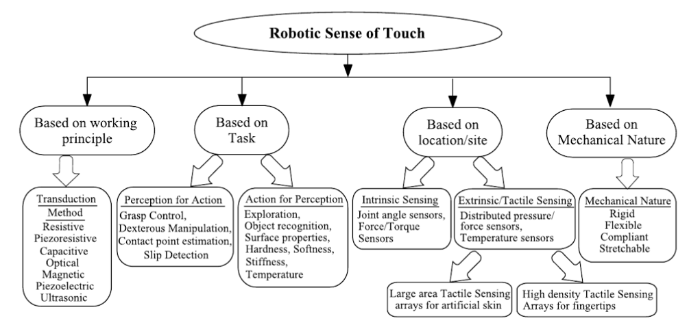

Sensors are applied in robot sensing. They provide analogs to human senses and can monitor other phenomena for which humans lack explicit sensors. These sensors can be classified into:

* Simple touch; knowing an object’s presence
* Proximity; non-contact detection
* Velocity sensors; measures consecutive position variations at known intervals
* Position sensors; determine an object’s position with respect to a predetermined location.
* Encoder. An optical digital device that converts motion into sequenced digital pulses
* Potentiometer
* Linear variable differential transformer. A displacement transformer that generates an ac signal whose magnitude is a function of a moving core

Another constantly borrowed concept in small robots is the basic line following robots. Concept of working of line follower is related to light. The behavior of light at black and white surface. When light falls on a white surface it is almost full reflected and in case of black surface light is completely absorbed. This behavior of light is used in building a line follower robot.

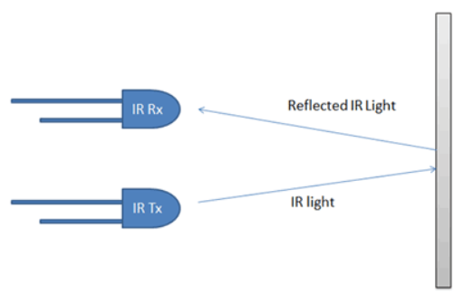

*Figure for white surface*

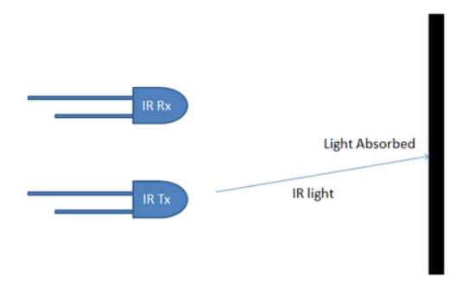

*Figure for dark surface*

In a line follower robot, IR receivers and transmitters also called photo diodes. They are used for sending and receiving light. When infrared light falls on a white surface, the rays behave differently as compared to when they fall on a dark surface, ideally black. On a white surface, they rays are reflected back to the IR receivers and this in turn generates a voltage level which is translated differently. On a black surface, light is absorbed and none is reflected back to the receivers hence the photo diodes do not generate any voltage. This clearly alerts the robot where the line is and where it is not.

Some of the sensors and components used to aid a robots motion are:

* Coils

An inductor, also called a coil, choke or reactor is a passive two-terminal electrical component that stores electrical energy in a magnetic field when electric current flows through it.

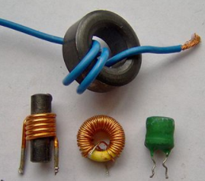

* Sound sensors LM386

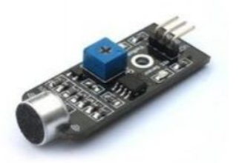

This sound sensor uses the onboard electret microphone as well as the LM386 amplifier to detect any sound that is beyond the threshold setting. The level of the threshold can be set by the on-board potentiometer. This module will output a HIGH signal when the sound is lower than the threshold, as well as LOW when the sound is higher than the threshold.

* Capacitors

A capacitor is a passive two-terminal electrical component that stores potential energy in an electric field. The effect of a capacitor is known as capacitance. While some capacitance exists between any two electrical conductors in proximity in a circuit, a capacitor is a component designed to add capacitance to a circuit. The capacitor was originally known as a condenser!

* Ultrasonic sensors

An Ultrasonic sensor is a device that can measure the distance to an object by using sound waves.

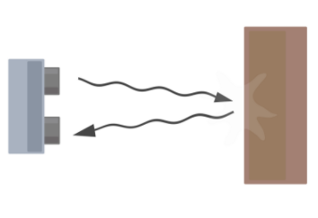

It measures distance by sending out a sound wave at a specific frequency and listening for that sound wave to bounce back. By recording the elapsed time between the sound wave being generated and the sound wave bouncing back, it is possible to calculate the distance between the sonar sensor and the object.

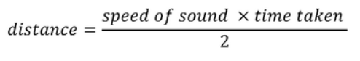

* Odometry sensor

Odometry is the use of data from motion sensors to estimate change in position over time. It is used in robotics by some legged or wheeled robots to estimate their position relative to a starting location. This method is sensitive to errors due to the integration of velocity measurements over time to give position estimates. Rapid and accurate data collection, instrument calibration, and processing are required in most cases for odometry to be used effectively.

* Perimeter receivers and transmitters

Perimeter receivers and transmitters are chips used in robots to help guide it and ensure it sticks to a mapped out region. They utilize coils to convert magnetic energy into electrical energy. The signal received is inversely proportional to the distance between the receiver and the transmitter. That is, the closer it is the stronger the signal.

* IMU (compass, gyro, accelerometer)

The IMU is an inertial measurement unit (IMU) that packs an L3GD20 3-axis gyro and an LSM303DLHC 3-axis accelerometer and 3-axis magnetometer onto a tiny 0.8″ × 0.5″ board. An I²C interface accesses nine independent rotation, acceleration, and magnetic measurements that can be used to calculate the sensor’s absolute orientation. The module includes a voltage regulator and a level-shifting circuit that allows operation from 2.5 to 5.5 V

* Motors

An electric motor is an electrical machine that converts electrical energy into mechanical energy. They are used in robots whose motion is based on wheels and not limbs.

* Motor drivers

A drive is the electronic device that harnesses and controls the electrical energy sent to the motor. The drive feeds electricity into the motor in varying amounts and at varying frequencies, thereby indirectly controlling the motor’s speed and torque.

* Lipo batteries

A lithium polymer battery, or more correctly lithium-ion polymer battery (abbreviated as LiPo, LIP, Li-poly, lithium-poly and others), is a rechargeable battery of lithium-ion technology using a polymer electrolyte instead of a liquid one. High conductivity semisolid (gel) polymers form this electrolyte. These batteries provide a higher specific energy than other lithium-battery types and are being used in applications where weight is a critical feature for example, tablet computers and cellular telephone handsets.

## 3.6 THE COMPLEXITIES OF ROBOT MOTION PLANNING

Motion planning is one of the biggest challenges faced in robotics. This is a term used in robotics to describe the process of breaking down a desired movement task into discrete motions that satisfy movement constraints while optimizing movement of the robot itself. It has many applications especially in autonomy.

The problem of planning a path of complete coverage of an environment by a mobile robot has not received significant research attention. Much of the focus of the research effort to date has centered on the problem of finding a path from a start location to a goal location, while minimizing one or more parameters such as length of path, energy consumption or journey time. A mobile robot should be capable of planning other kinds of paths, such as have the capability to find paths, which ensure the complete coverage of an environment. Possible applications of such paths include autonomous vacuum cleaners, lawn mowers, security robots, land mine detectors etc. Complete coverage

Paths can also allow a robot to systematically explore and map unknown terrains. This paper will presents a solution to the problem of complete coverage based upon an extension to the distance transform path planning methodology. Experimental results are presented by way of simulation and an implementation on the Yamabico mobile robot.

One technique proposed by the makers of the Yamabiko robot is the path of complete coverage. The diagram below shows an illustration of this method.

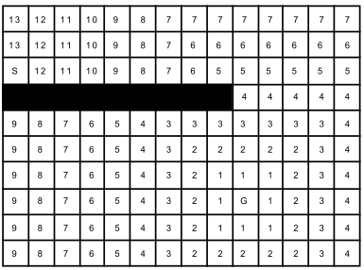

*Fig (a) - yamabiko showing the marking of grid points. The shaded region marks already cleaned potions of the floor*

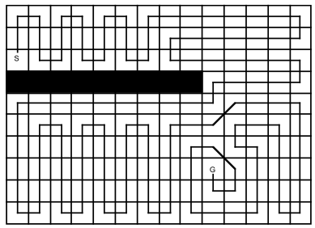

*Fig (b) – yamabiko showing the motion of the bot to ensure all potions are cleaned.*

An advantage of this complete coverage strategy is that the start and goal can be specified. This is useful if for example, if a warehouse floor that needs to be cleaned. The robot can start at one end of the warehouse and end up at the other end, ready to enter the next warehouse. While this strategy does not guarantee the "complete coverage" path will be an optimum path i.e. the shortest possible and not unnecessarily visiting any cell more than once, the "complete coverage" produces a reasonable path with minimal secondary visits to grid cells. To find the optimum

solution to this problem is equivalent to solving the Traveling Salesman's Problem. Each grid cell can be regarded as city with each city connected up to eight other cities.

Closer observation of the above described path of complete coverage shows that the path produces too many turns. This is because the coverage path follows the "spiral" of the distance transform wave front that radiated from the goal. In certain configurations of obstacles in an environment, this can produce unsatisfactory paths. Complete coverage paths of the type shown in Fig*. (b)* are difficult to execute on a mobile robot that navigates by dead reckoning.

The high number of turns and path segments will inevitably cause errors to be introduced in the estimation of the robot's correct position. Possibly for these reasons an implementation of complete coverage paths on an actual mobile robot has not been reported. A possible solution would be to use external navigation beacons. However, this adds artificial structure to the environment. It is our aim to conduct experimental work in unstructured environments.

Basic motion planning involves connecting a start configuration and goal achievement while avoiding all obstacles between these two points. Terms such as configuration space are used to refer to the set of all possible configurations between the start and goal points. This configuration space can be 2D or 3D in reference to all the points in the workspace.

Free space, Cfree, is the set of configurations that ensure the robot does not collide with any obstacles along the path. Target space is a linear subspace of free space that indicated where we desire the robot to go. A linear subspace also known as vector subspace is a vector space that is a subset of a higher dimension. In robot motion, planning various concepts such as Grid-based search and Interval-based search can be employed.

Grid-based approaches overlay a grid on configuration space, and assume each configuration is identified with a grid point. At each grid point, the robot is allowed to move to adjacent grid points as long as the line between them is completely contained within the free space. Despite interval- based search having similarities to grid- based search, it generates a paving covering the entire configuration space instead of a grid.

CHAPTER 4

# 4. METHODOLOGY

## 4.1 Project modules

For this project to be achieved it has to be broken down into modules each having an individual purpose but contributing to the end result. The aim of dividing our project into modules is for the sole purpose of efficiency and utilization of available man-power to ensure that the end product is at the best possible condition as can be taking into account available resources, man-power and individual skills.

KELVIN KIHUMBA

* Obstacle avoidance

Use range sensors to identify obstacles and their distance from the robot by sending high frequency sound waves and evaluate the echo received by the sensor. This will enable the robot to navigate through a practical field.

* Driving module

Sensor and programming integration to allow it to move through the lawn/field in a pattern that ensures every piece of land is covered.

* Integrate to an android smartphone

This will involve the creation of an user interface application that can be installed in an android smartphone.

IAN KAIMENYI

* Input adjustments

User interface integration using programming to enable localization of the robot to a specific part of the field.

* Power requirements

Horse power design equations (power to weight ratio) and power distribution throughout all components.

* Perimeter recognition

Determine the position of the robot on the field (at any time) using Local Positioning System and also evaluate the shape and dimensions of the same field, then restrict the robot to these dimensions.

BOTH

* Acquisition

Determine the specific components required for the model realization and make plans to acquire them.

* Fabrication

Build and assemble the model that will illustrate and bring into realization the practical implementation of this project.

## 4.2 Top Down design

### 4.2.1 Device Requirements and Analysis

To develop an efficient automower, various field scenarios have to be taken into account and simulations done where possible. This will help in determination of factors such as weight to torque ratio.

### 4.2.2 Navigation and Guidance System

The actual state of the robot can be described completely by:

1. speed (m/s)
2. direction (degree)
3. position (x,y - meter)

All sensors (gyro, acceleration, compass, odometry, perimeter signal strength, GPS…) can deliver certain information about the robot's state. However, each sensor is noisy (added with errors). Sensor fusion is used to eliminate errors of each individual sensor. Each sensor gets a confidence weight that is automatically adjusted after reading the sensor by comparing its plausibility with the fusion result. Since the robot will be mobile, a defined means of movement that ensures efficiency will be designed and calculations made where necessary to meet the requirements of the end device.

The guidance of the system within the virtual fence will involve electromagnetic knowledge and application by use of a perimeter wire. A perimeter wire is like a virtual fence, it stops the robot when it reaches its boundaries. A perimeter wire will be installed through which a signal will be sent and the robot will detect the signal. This means that we will employ a sender to transmit on the wire and a receiver module on the robot to detect the signal.

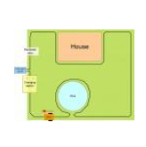

Sample setting of a perimeter wire on a field.

Once the robot crosses the wire, something interesting happens: the signal changes its polarity, that means negative and positive voltages reverse. By using this principle, crossing the perimeter wire as well as the current state (robot is inside/outside) can be detected.

The perimeter sender outputs a digital code sequence (pseudo-noise) and the receiver will detect the signal. Depending on whether the match result is peak positive or negative the robot is inside or outside the perimeter wire as the diagrams below illustrate.

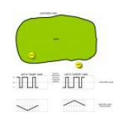 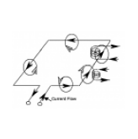

Inside/outside the area flux directions

### 4.2.3 Hardware Configuration and Testing

According to the circuit diagrams, the components will be connected and soldered together where need be in order to convert individual pieces into a solid functional device. An instruction manual shall be provided along with the end device in order to aid in efficient usage.

### 4.2.4 Integration and Testing

Components such as a display device and input keypad shall also be integrated into the device and tested fully.

### 4.2.5 Module Testing

This phase will involve testing of individual modules such as obstacle avoidance module, in an effort to ensure each module is fully functional before getting integrated into the end device.

### 4.2.6 Integration Testing

This phase comes after individual modules have been tested. It will involve integrating module by module while continuously testing that the interfacing of each micro system to the other is at it’s optimum. The end of this phase will result in a fully functional end device.

### 4.2.7 System Testing

This will be the final testing phase after modules have been created, tested and integrated with one another. It will check on the effectiveness of the end device against the provided parameters by the project developers.

## 4.3 Implementation

Once all modules have been acquired and all interfacing programs and pieces of code added to specific parts, this stage will involve the creation of the end device, which will be a small robot that has the ability to navigate a specified field and ideally ‘mow’ the entire field. It will however, not involve a cutting blade, as this is a model. The end robot and the released documentation will provide the option and guide for any user to add a cutting blade should they desire to do so.

## 4.4 Software and Design Simulations

The design phase will need simulation. This will be done through software such as circuit make, NI Multism instruments and/or Proteus. The results obtained from the simulations will be included and will be utilized to ensure the end device is achieved.

CHAPTER 5

# 5. EXPECTED RESULTS

1. It is expected that at the end a mobile robot will be achieved
2. The end robot is expected to be able to stick to a region specified by a perimeter wire or buried wire fence (BWF)
3. Simulations of the amplification of the sent and received signals are expected along with the end device.
4. The robot is expected to be able to communicate with an android smartphone
5. The robot is expected to navigate the field autonomously while avoiding obstacles
6. In the face of obstacles its expected to avoid them and return to the path in which it was.
7. It expected that we build, test and implement a working and stable intelligent lawn mower model

# 6. PROJECT TIME PLAN

|  |  |  |  |  |  |  |  |  |  |
| --- | --- | --- | --- | --- | --- | --- | --- | --- | --- |
| **ACTIVITY** | **SEM 1** | | | | | **SEM 2** | | | |
| **SEP** | **OCT** | **NOV** | **DEC** | **JAN** | **FEB** | **MAR** | **APRIL** | **MAY** |
| **DOCUMENTATION** |  |  |  |  |  |  |  |  |  |
| **RESEARCH AND LITARATURE REVIEW** |  |  |  |  |  |  |  |  |  |
| **PROGRESS REPORT 1** |  |  |  |  |  |  |  |  |  |
| **PROJECT PROPOSAL** |  |  |  |  |  |  |  |  |  |
| **1ST PRESENTATION** |  |  |  |  |  |  |  |  |  |
| **DESIGN AND CODING** |  |  |  |  |  |  |  |  |  |
| **PROGRESS REPORT 2** |  |  |  |  |  |  |  |  |  |
| **ROBOT BUILDING** |  |  |  |  |  |  |  |  |  |
| **PROJECT REPORT WRITING** |  |  |  |  |  |  |  |  |  |
| **PROGRESS REPORT 3** |  |  |  |  |  |  |  |  |  |
| **FINAL PROJECT PRESENTATION** |  |  |  |  |  |  |  |  |  |

## 6.1 PROPOSED PROJECT BUDGET

|  |  |  |  |
| --- | --- | --- | --- |
| **ITEM** | **QUANTITY** | **PRICE PER PIECE** | **AMOUNT IN KSH.** |
| Ultrasonic sensors | 3 | 400 | 1200 |
| Odometry sensor | 2 |  |  |
| Perimeter receiver | 2 |  |  |
| Perimeter transmitter | 1 |  |  |
| IMU | 1 | 1400 | 1400 |
| Motors | 2 |  |  |
| Wheels | 3 | 200 | 600 |
| Bluetooth module | 1 | 1000 | 1000 |
| Motor driver and shield L298N | 2 each | 500 | 2000 |
| Battery (Li-Po) and charger | 1 | 1300 | 1300 |
| Button | 4 | 10 | 40 |
| Arduino | 2 | 1000 | 2000 |
| Sound sensors | 2 | 250 | 500 |
| Components (RLC) |  | NA | 600 |
| **TOTAL** |  |  |  |

## 6.2 LIST OF FIGURES

1. Push mower sketch



1. Ride on lawn mowers

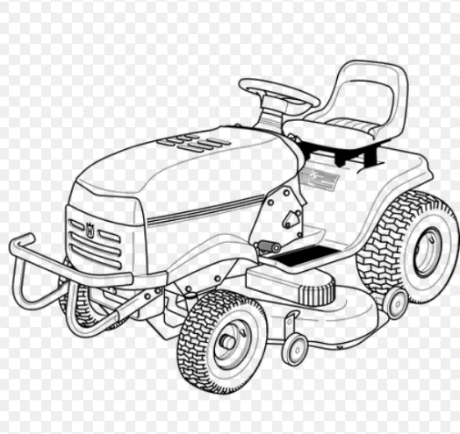

1. Push reel mower

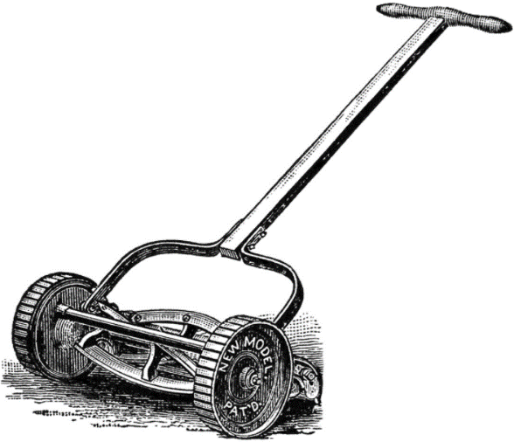

# 7. REFERENCES

1. "What is a Motor Drive? | Kaman Automation", *Kaman Automation*, 2017. [Online]. Available: http://kamanautomation.com/info-center/supplier-resources/what-is-a-motor-drive/. [Accessed: 06- Dec- 2017].
2. S. Mraz, "What’s the Difference Between a Motor and a Drive?", *Machine Design*, 2017. [Online]. Available: http://www.machinedesign.com/motorsdrives/what-s-difference-between-motor-and-drive. [Accessed: 13- Dec- 2017].
3. "Robot Motion", *Google Books*, 2018. [Online]. Available: https://books.google.co.ke/books?id=40L4udpG1m4C&printsec=frontcover&dq=robot+motion+planning+and+control&hl=en&sa=X&ved=0ahUKEwjJ17ib19vYAhXjBcAKHRFmCu8Q6AEIJjAA#v=onepage&q=robot motion planning and control&f=false. [Accessed: 06- Jan- 2018].
4. "Robot Motion Planning", *Google Books*, 2018. [Online]. Available: https://books.google.co.ke/books?id=nQ7aBwAAQBAJ&printsec=frontcover&dq=robot+motion+planning+and+control&hl=en&sa=X&ved=0ahUKEwjJ17ib19vYAhXjBcAKHRFmCu8Q6AEIMDAC#v=onepage&q=robot motion planning and control&f=false. [Accessed: 06- Jan- 2018].
5. "Robot Motion and Control 2011", *Google Books*, 2018. [Online]. Available: https://books.google.co.ke/books?id=_f7qBwAAQBAJ&printsec=frontcover&dq=robot+motion+planning+and+control&hl=en&sa=X&ved=0ahUKEwjJ17ib19vYAhXjBcAKHRFmCu8Q6AEIPDAE#v=onepage&q=robot motion planning and control&f=false. [Accessed: 06- Jan- 2018].
6. "Mobile Robots in Rough Terrain", *Google Books*, 2017. [Online]. Available: https://books.google.co.ke/books?id=JLTVa-hBn6wC&printsec=frontcover&dq=robot+motion+planning+and+control&hl=en&sa=X&ved=0ahUKEwjJ17ib19vYAhXjBcAKHRFmCu8Q6AEISDAG#v=onepage&q=robot motion planning and control&f=false. [Accessed: 10- Dec- 2017].
7. B. Siciliano, L. Sciavicco, L. Villani and G. Oriolo, *Robotics*. London: Springer, 2010.
8. H. Bunke, T. Kanade and H. Noltemeier, *Modelling and planning for sensor based intelligent robot systems*. Singapore: World Scientific, 1995.
9. *Mobile Robotics*. World Scientific, 2009.
10. S. LaValle, *Planning algorithms*. New York (NY): Cambridge University Press, 2014.
11. R. Dahiya and M. Valle, *Robotic tactile sensing*. Dordrecht: Springer, 2013.
12. M. Cazorla Quevedo and J. Garcia-Rodriguez, *Robotic vision*. Hershey, Pa.: IGI Global, 2013.
13. P. Maji, A. Ghosh, M. Murty, K. Ghosh and S. Pal, *Pattern Recognition and Machine Intelligence*. Berlin, Heidelberg: Imprint: Springer, 2013.
14. W. Blackstone and T. Cooley, *Commentaries on the laws of England*. Clark, N.J.: Lawbook Exchange, 2003.
15. W. Blackstone and T. Cooley, *Commentaries on the laws of England*. Clark, N.J.: Lawbook Exchange, 2003.
16. P. Perner, *Machine Learning and Data Mining in Pattern Recognition*. .
17. K. Dautenhahn and J. Saunders, *New frontiers in human-robot interaction*. Philadelphia: John Benjamins Pub., 2011.
18. P. Hinds, H. Ishiguro and P. Hinds, *HRI 2010 : 5th ACM/IEEE International Conference on Human-Robot Interaction : March 2-5 2010, Osaka, Japan*. .
19. M. Beetz, *Advances in plan-based control of robotic agents*. Berlin: Springer, 2002.
20. J. Warren, J. Adams and H. Molle, *Arduino Robotics*. Berkeley, CA: Apress, 2011.